What are Some Points to Consider in a Vulnerability Assessment?

Some points to consider related to the six basic elements are included in the following tables. The manner in which the vulnerability assessment is performed is determined by each individual water utility. It will be helpful to remember throughout the assessment process that the ultimate goal is twofold: to safeguard public health and safety, and to reduce the potential for disruption of a reliable supply of pressurized water.

Basic Element | Points to Consider
1. Characterization of the water system, including its mission and objectives.  (Answers to system-specific questions may be helpful in characterizing the water system.) | What are the important missions of the system to be assessed? Define the highest priority services provided by the utility. Identify the utility’s customers:  - General public  - Government  - Military  - Industrial  - Critical care  - Retail operations  - Firefighting  What are the most important facilities, processes, and assets of the system for achieving the mission objectives and avoiding undesired consequences? Describe the:  - Utility facilities  - Operating procedures  - Management practices that are necessary to achieve the mission objectives  - How the utility operates (e.g., water source including ground and surface water)  - Treatment processes  - Storage methods and capacity  - Chemical use and storage  - Distribution system  In assessing those assets that are critical, consider critical customers, dependence on other infrastructures (e.g., electricity, transportation, other water utilities), contractual obligations, single points of failure (e.g., critical aqueducts, transmission systems, aquifers, etc.), chemical hazards and other aspects of the utility’s operations, or availability of other utility capabilities that may increase or decrease the criticality of specific facilities, processes and assets.

Basic Element | Points to Consider
2. Identification and prioritization of adverse consequences to avoid. | Take into account the impacts that could substantially disrupt the ability of the system to provide a safe and reliable supply of drinking water or otherwise present significant public health concerns to the surrounding community. Water systems should use the vulnerability assessment process to determine how to reduce risks associated with the consequences of significant concern.  Ranges of consequences or impacts for each of these events should be identified and defined. Factors to be considered in assessing the consequences may include:  - Magnitude of service disruption  - Economic impact (such as replacement and installation costs for damaged critical assets or loss of revenue due to service outage)  - Number of illnesses or deaths resulting from an event  - Impact on public confidence in the water supply  - Chronic problems arising from specific events  - Other indicators of the impact of each event as determined by the water utility.  Risk reduction recommendations at the conclusion of the vulnerability assessment should strive to prevent or reduce each of these consequences.

Basic Element | Points to Consider
3. Determination of critical assets that might be subject to malevolent acts that could result in undesired consequences. | What are the malevolent acts that could reasonably cause undesired consequences? Consider the operation of critical facilities, assets and/or processes and assess what an adversary could do to disrupt these operations. Such acts may include physical damage to or destruction of critical assets, contamination of water, intentional release of stored chemicals, interruption of electricity or other infrastructure interdependencies.  The “Public Health Security and Bioterrorism Preparedness and Response Act of 2002” (PL 107-188) states that a community water system which serves a population of greater than 3,300 people must review the vulnerability of its system to a terrorist attack or other intentional acts intended to substantially disrupt the ability of the system to provide a safe and reliable supply of drinking water. The vulnerability assessment shall include, but not be limited to, a review of:  - Pipes and constructed conveyances  - Physical barriers  - Water collection, pretreatment and treatment facilities  - Storage and distribution facilities  - Electronic, computer or other automated systems which are utilized by the public water system (e.g., Supervisory Control and Data Acquisition (SCADA))  - The use, storage, or handling of various chemicals  - The operation and maintenance of such systems.

Basic Element | Points to Consider
4. Assessment of the likelihood (qualitative probability) of such malevolent acts from adversaries (e.g., terrorists, vandals). | Determine the possible modes of attack that might result in consequences of significant concern based on the critical assets of the water system. The objective of this step of the assessment is to move beyond what is merely possible and determine the likelihood of a particular attack scenario. This is a very difficult task as there is often insufficient information to determine the likelihood of a particular event with any degree of certainty.  The threats (the kind of adversary and the mode of attack) selected for consideration during a vulnerability assessment will dictate, to a great extent, the risk reduction measures that should be designed to counter the threat(s). Some vulnerability assessment methodologies refer to this as a “Design Basis Threat” (DBT) where the threat serves as the basis for the design of countermeasures, as well as the benchmark against which vulnerabilities are assessed. It should be noted that there is no single DBT or threat profile for all water systems in the United States. Differences in geographic location, size of the utility, previous attacks in the local area and many other factors will influence the threat(s) that water systems should consider in their assessments. Water systems should consult with the local FBI and/or other law enforcement agencies, public officials, and others to determine the threats upon which their risk reduction measures should be based. Water systems should also refer to EPA’s “Baseline Threat Information for Vulnerability Assessments of Community Water Systems” to help assess the most likely threats to their system. This document is available to community water systems serving populations greater than 3,300 people. If your system has not yet received instructions on how to receive a copy of this document, then contact your Regional EPA Office immediately. You will be sent instructions on how to securely access the document via the Water Information Sharing and Analysis Center (ISAC) website or obtain a hardcopy that can be mailed directly to you. Water systems may also want to review their incident reports to better understand past breaches of security.

Basic Element | Points to Consider
5. Evaluation of existing countermeasures.  (Depending on countermeasures already in place, some critical assets may already be sufficiently protected. This step will aid in identification of the areas of greatest concern, and help to focus priorities for risk reduction.) | What capabilities does the system currently employ for detection, delay and response?  - Identify and evaluate current detection capabilities such as intrusion detection systems, water quality monitoring, operational alarms, guard post orders, and employee security awareness programs.  - Identify current delay mechanisms such as locks and key control, fencing, structure integrity of critical assets and vehicle access checkpoints.  - Identify existing policies and procedures for evaluation and response to intrusion and system malfunction alarms, adverse water quality indicators, and cyber system intrusions.  It is important to determine the performance characteristics. Poorly operated and maintained security technologies provide little or no protection.  What cyber protection system features does the utility have in place? Assess what protective measures are in place for the SCADA and business-related computer information systems such as:  - Firewalls  - Modem access  - Internet and other external connections, including wireless data and voice communications  - Security policies and protocols  It is important to identify whether vendors have access rights and/or “backdoors” to conduct system diagnostics remotely.  What security policies and procedures exist, and what is the compliance record for them? Identify existing policies and procedures concerning:  - Personnel security  - Physical security  - Key and access badge control  - Control of system configuration and operational data  - Chemical and other vendor deliveries  - Security training and exercise records

Basic Element | Points to Consider
6. Analysis of current risk and development of a prioritized plan for risk reduction. | Information gathered on threat, critical assets, water utility operations, consequences, and existing countermeasures should be analyzed to determine the current level of risk. The utility should then determine whether current risks are acceptable or risk reduction measures should be pursued.  Recommended actions should measurably reduce risks by reducing vulnerabilities and/or consequences through improved deterrence, delay, detection, and/or response capabilities or by improving operational policies or procedures. Selection of specific risk reduction actions should be completed prior to considering the cost of the recommended action(s). Utilities should carefully consider both short- and long-term solutions. An analysis of the cost of short- and long-term risk reduction actions may impact which actions the utility chooses to achieve its security goals.  Utilities may also want to consider security improvements in light of other planned or needed improvements. Security and general infrastructure may provide significant multiple benefits. For example, improved treatment processes or system redundancies can both reduce vulnerabilities and enhance day-to-day operation.  Generally, strategies for reducing vulnerabilities fall into three broad categories:  - Sound business practices – affect policies, procedures, and training to improve the overall security-related culture at the drinking water facility. For example, it is important to ensure rapid communication capabilities exist between public health authorities and local law enforcement and emergency responders.  - System upgrades – include changes in operations, equipment, processes, or infrastructure itself that make the system fundamentally safer.  - Security upgrades – improve capabilities for detection, delay, or response.

1. Characterization of Water System, Including Mission and Objectives

Your water system was formulated to achieve certain objectives for your community. These are commonly expressed in a mission statement. Common objectives are:

- Provide safe drinking water to all members of the community
- Provide fire protection to the community

The goal of this section is to identify what your system wants to maintain during an emergency or disaster. This might include critical people (political, water system staff, etc.) and customers (hospitals, enforcement agencies, etc.) in addition to your water system’s key facilities.

Further, the characterization of your system should include a schematic of your system components from source(s) to tap. Remember to include items such as power and roads as elements of your system.

Example Mission Statement

Sample of a Mission Statement and objectives during an emergency or disaster:

Mission Statement

The City of XYZ Department of Water has been created to provide the following services for the community and its citizens:
- To supply safe drinking water in accordance with California and Federal regulations.
- To maintain sufficient water pressure in the drinking water system to ensure successful fire protection.
- Provision of water to critical facilities .

Example: See page 8 for a sample schematic diagram of a combined surface and ground water system and description of how it operates.

Form: There is no form for this section. Please use the samples and examples in this section to construct your system schematic and description of operations.

Example Water Utility

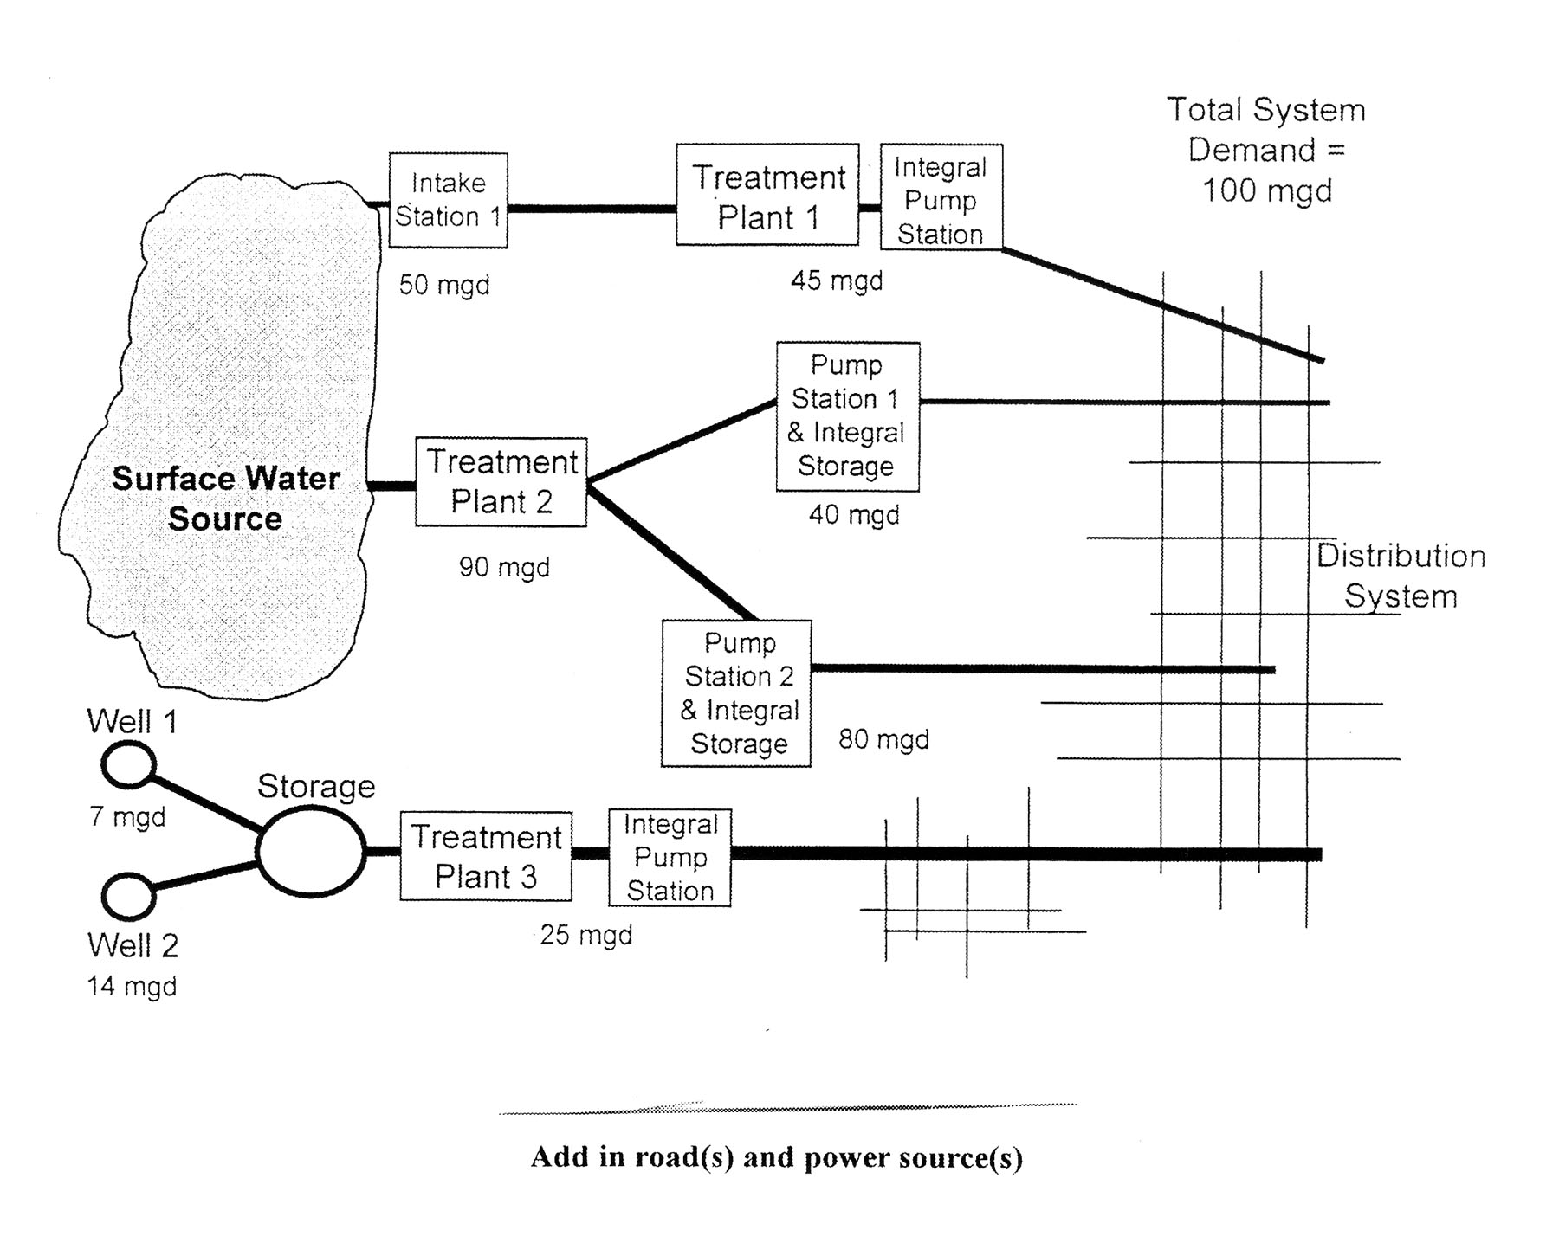

Add in road(s) and power source(s)

Include: sources/treatment/storage

SCADA/sensors

valves, gates

Add written descriptions as needed

2. Identification and Prioritization of Adverse Consequences to Avoid

This is directly from the EPA guidance for this section.

When considering adverse consequences, the water system should take into account the impacts that could substantially disrupt the ability of the system to provide a safe and reliable supply of drinking water or otherwise present significant public health concerns to the surrounding community. In general, water systems should use the vulnerability assessment process to determine how to reduce risks associated with the consequences of significant concern.

Ranges of consequences or impacts for each of these events should be identified and defined. Factors to be considered in assessing the consequences may include: magnitude of service disruption; economic impact (such as replacement and installation costs for damaged critical assets or loss of revenue due to service outage); number of illnesses or deaths resulting from an event; impact on public confidence in the water supply; chronic problems arising from specific events; or other indicators of the impact of each event as determined by the water utility. Risk reduction recommendations at the conclusion of the vulnerability assessment should strive to prevent or reduce each of these consequences.

Thus this point has two parts: to identify potential threats and to prioritize these threats based on the severity of consequences. Using the following form, name each threat you can think of and the asset to which it is a threat. Once you have identified the potential threats, use the column labeled “Severity of Consequences” and rate them using the suggested factors listed on the form.

Example: See page 10.

Form: See page 11.

Sample Risk Assessment

Threat # | Threat Name | Probability of Occurrence (P) | Severity of Consequence (C) | Effectiveness of Deterrents (E) | Relative  Risk (R=PxCxE)
1 | Spill – Surface Water Source |  | 2
2 | Power Loss – Intake Station 1 |  | 2
3 | Power Loss – Treatment Plant 2 |  | 3
4 | Vandalism – Surface Water Source |  | 2
5 | Sabotage – Surface Water Source |  | 2
6 | Terrorism – Surface Water Source |  | 3
7 | Natural Disaster – Surface Water Source |  | 1
8 | Spill – Well 1 |  | 1
9 | Power Loss – Well 1 |  | 1
10 | Vandalism – Well 1 |  | 1
11 | Sabotage – Well 1 |  | 1
12 | Terrorism – Well 1 |  | 1
13 | Natural Disaster – Well 1 |  | 1
14 | Spill – Well 2 |  | 1
15 | Power Loss – Well 2 |  | 1
16 | Vandalism – Well 2 |  | 1
17 | Sabotage – Well 2 |  | 1
18 | Terrorism – Well 2 |  | 1
19 | Natural Disaster – Well 2 |  | 1
20
21
22
23
24
25
26
27
28
29
30
31
32
33
34
35

SUGGESTED FACTORS FOR P, E, AND C

Probability of Occurrence (P)  Not likely to happen 1  Not likely but possible 2  Could happen and is likely 3  Likely (has happened) 4  Consequence of Action (C)  Low 1  Medium 2  High 3 | Effectiveness of Deterrents (E)  Highly Effective 1  Moderately Effective 2  Ineffective 3

Risk Assessment

Threat # | Threat Name | Probability of Occurrence (P) | Severity of Consequence (C) | Effectiveness of Deterrents (E) | Relative  Risk (R=PxCxE)
1
2
3
4
5
6
7
8
9
10
11
12
13
14
15
16
17
18
19
20
21
22
23
24
25
26
27
28
29
30
31
32
33
34
35

SUGGESTED FACTORS FOR P, E, AND C

Probability of Occurrence (P)  Not likely to happen 1  Not likely but possible 2  Could happen and is likely 3  Likely (has happened) 4  Consequence of Action (C)  Low 1  Medium 2  High 3 | Effectiveness of Deterrents (E)  Highly Effective 1  Moderately Effective 2  Ineffective 3

Determination of Critical Assets that Might Be Subject to Malevolent Acts

that Could Result in Undesired Consequences

This section can be looked at as a double check to ensure you identified all the potential threats. Look at your schematic and list all your system’s assets. You will probably also want to list critical facilities that you serve or which serve you. Using the sample list and your system schematic you should be able to make a complete list. Once you have completed the list, review your potential threat list and add any additional potential threats that are revealed by creating this list. You will also want to rate them in the “Severity of Consequence” column of the Risk Assessment Form. In addition, you will want to identify which of these assets are critical by placing a C in the “Critical Asset” column of the Critical Asset Form. Some criteria for determining whether it is a critical asset would include:

- If this item fails or is destroyed will your system be inoperable?

- If this item is contaminated, will your system become in effect a lethal weapon to most of the community?

This list will be also be used later when we consider possible risk reductions.

Sample: See page 13.

Form: See page 14.

Example Inventory of System Critical Components

Component | Number & Location (if applicable) | Description | Critical Asset  or  Single Point of Failure (H/M/L)
Source Water Type
Ground Water | 2 | Well 1, well 2 | L
Surface Water | 2 | Intake 1, intake 2 | M
Treatment Plant
Buildings | 3 | 3 Treatment plants | M
Pumps | 6 | 3 raw water pumps, 3 clear water pumps | H
Treatment Equipment  (e.g.; basin, clear well, filter) | 1 | Flocculation/sedimentation basin | M
Treatment Equipment  (e.g.; basin, clear well, filter) | 1 | Filter system | M
Treatment Equipment  (e.g.; basin, clear well, filter) | 1 | Clear well | M
Process Controls | 1 set | Monitoring charts in building | M
Treatment Chemicals and Storage | 1,000 gal and 2 1-ton cylinders of anhydrous ammonia | Aluminum sulfate, chlorine gas, and ammonia | M
Laboratory Chemicals and Storage | 25 lbs total | Various test reagents | M
Storage
Storage Tanks | 1 | Ground level tank | M
Pressure Tanks | 0 |  | NA
Power
Primary Power | 1 | PGE | M
Auxiliary Power | 0 |  | NA
Distribution System
Pumps | 1 | Pump to tank | H
Pipes | 50 miles | 40 miles of distribution (mostly 6 inch), 10 miles of transportation (12 inch) | L/H
Valves-Important | 14 | Treatment plant, and Main Line valves | H
Valves-Street | Numerous | 160 gate valves in distribution system | L
Appurtenances (e.g., flush hydrants, backflow preventers, meters) | 300  8  5 | Fire hydrants  RP devices  4 intake/ 1 treatment outlet | L  M  L
Other Vulnerable Points | NA |  | NA
Offices
Buildings | 1 | Main office | L
Computers | 1 | Main office | L
Files | 100 | Main office | L
Transportation/ Work Vehicles | 4 | Service pickups | L
Personnel | 5 | 3 operations, 1 supervisor, 1 maintenance | Depends on who you lose
Communications
Telephone | 1 | Office phone | L
Cell Phone | 4 | Cell phone | L
Radio | 4 | Short-wave Radio | L
Computer Control Systems (SCADA) | 1 | One main computer | L
Critical Facilities Served
Hospitals | 1 | General Hospital | M
Schools | 3 | 2 elementary, 1 high school | M
Waste Water Treatment Plants | 0 |  | NA
Food/Beverage Processing Plants | 0 |  | NA
Nursing Homes | 1 | Golden Acres | M
Prisons/Other Institutions | 0 |  | NA

Inventory of System Critical Components

Component | Number & Location (if applicable) | Description | Critical Asset  or  Single Point of Failure (H/M/L)
Source Water Type
Ground Water
Surface Water
Purchased Water
Treatment Plant
Buildings
Pumps
Treatment Equipment
(e.g.; basin, clear well, filter)

Process Controls
Treatment Chemicals and Storage
Laboratory Chemicals and Storage
Storage
Storage Tanks
Pressure Tanks
Power
Primary Power
Auxiliary Power
Distribution System
Pumps
Pipes
Valves
Appurtenances (e.g., flush hydrants, backflow preventers, meters)
Other Vulnerable Points
Offices
Buildings
Computers
Files
Transportation/Work Vehicles
Personnel
Communications
Telephone
Cell Phone
Radio
Computer Control Systems (SCADA)
Critical Facilities Served
Power Plant Failures
Hospitals
Schools
Waste Water Treatment Plants
Food/Beverage Processing Plants
Nursing Homes
Prisons/Other Institutions

4. Assessment of Likelihood of Attack
(Qualitative Probability) of Such Malevolent Acts from Adversaries (e.g. Terrorists, Vandals)

Per the EPA guidance, “It should be noted that there is no single Design Basis Threat (DBT) or threat profile for all water systems in the United States. Differences in geographic location, size of utility, previous attacks in the local area, and many other factors will influence the threat(s) that water systems should consider in their assessments. From this perspective, water systems should consult with the local FBI and/or other law enforcement agencies, public officials, and others to determine threats upon which their risk reduction measures should be based. Utilities may also want to review their incident reports to better understand past breaches of security.”

Continue using your Risk Assessment form and now assign a Probability of Occurrence based on the suggested factors to each of the identified threats. When assigning this probability, you will want to consider all the items listed above. In addition, you will note that the sample includes other probability factors that may apply to your system.

Sample: See page 16.

Form: No new form, continue your Risk Assessment Worksheet (page 11).

Sample Risk Assessment

Threat # | Threat Name | Probability of Occurrence (P) | Severity of Consequence (C) | Effectiveness of Deterrents (E) | Relative  Risk (R=PxCxE)
1 | Spill – Surface Water Source | 1 | 2
2 | Power Loss – Intake Station 1 | 2 | 2
3 | Power Loss – Treatment Plant 2 | 3 | 3
4 | Vandalism – Surface Water Source | 1 | 2
5 | Sabotage – Surface Water Source | 1 | 2
6 | Terrorism – Surface Water Source | 1 | 3
7 | Natural Disaster – Surface Water Source | 1 | 1
8 | Spill – Well 1 | 1 | 1
9 | Power Loss – Well 1 | 1 | 1
10 | Vandalism – Well 1 | 1 | 1
11 | Sabotage – Well 1 | 1 | 1
12 | Terrorism – Well 1 | 1 | 1
13 | Natural Disaster – Well 1 | 1 | 1
14 | Spill – Well 2 | 1 | 1
15 | Power Loss – Well 2 | 2 | 1
16 | Vandalism – Well 2 | 2 | 1
17 | Sabotage – Well 2 | 1 | 1
18 | Terrorism – Well 2 | 1 | 1
19 | Natural Disaster – Well 2 | 1 | 1
20
21
22
23
24
25
26
27
28
29
30
31
32
33
34
35

SUGGESTED FACTORS FOR P, E, AND C

Probability of Occurrence (P)  Not likely to happen 1  Not likely but possible 2  Could happen and is likely 3  Likely (has happened) 4  Consequence of Action (C)  Low 1  Medium 2  High 3 | Effectiveness of Deterrents (E)  Highly Effective 1  Moderately Effective 2  Ineffective 3

5. Evaluation of Existing Countermeasures

At this point you are ready to walk through your entire system. The forms provided will ask 45 yes/no questions and give you specific comments to help you thoroughly assess your system’s current security measures. Once you have completed this template, you will have a good basis for determining the “Effectiveness of Deterrents” column on the Risk Assessment form.

Sample: see page 46 for an example of a Risk Assessment form partially filled in using the data obtained from the self-assessment forms.

Blank Forms: see Section C for blank self-assessment forms for your use.

You already have a working Risk Assessment Form to use.

